The
Trimming Flowchart
Workbook

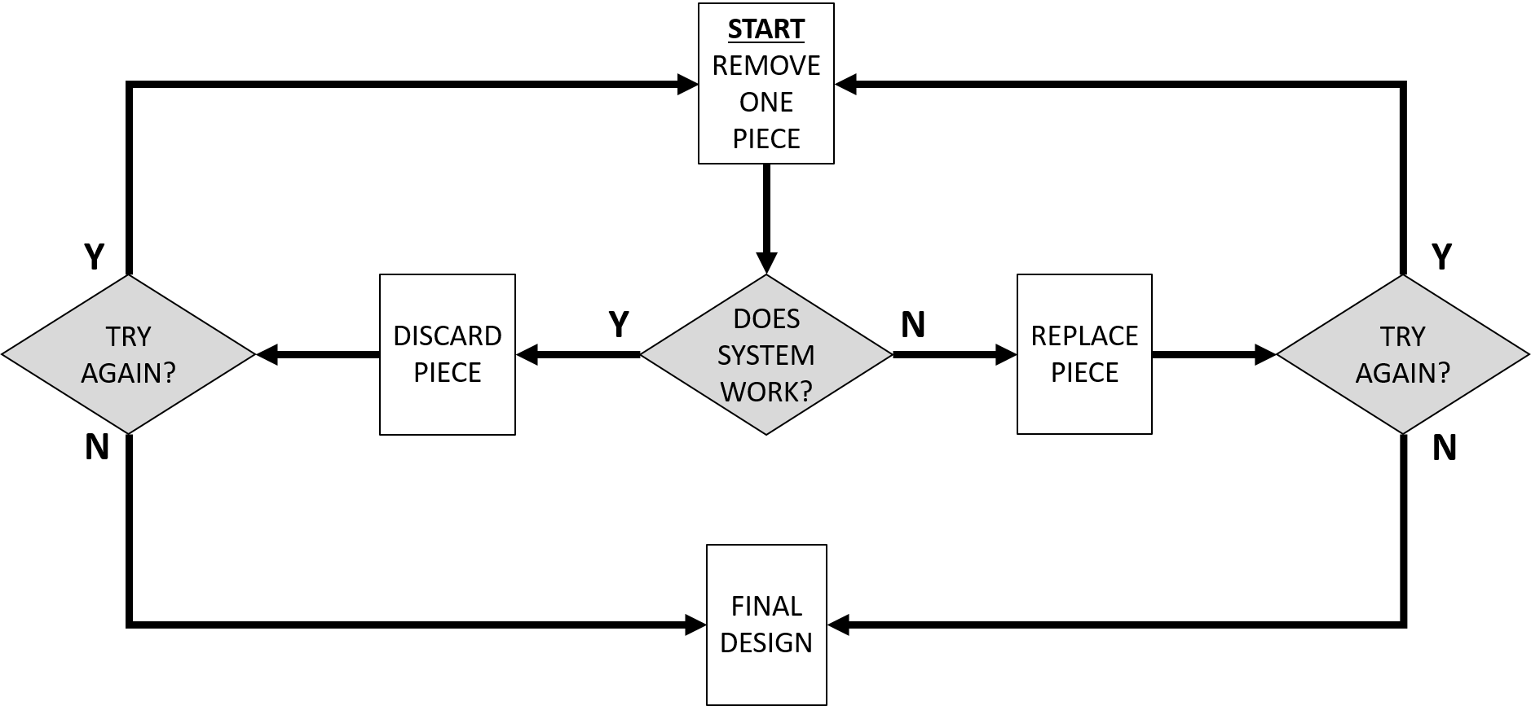

By Dan Ward
Jan 2017

Approved for Public Release; Distribution Unlimited. Case Number 17-0266
©2017 The MITRE Corporation. All Rights Reserved.

INTRODUCTION

Trimming is a powerful reductive practice that streamlines a design down to its essential elements. It provides a disciplined, structured approach to reducing unnecessary complexity and helps produce a more elegant, streamlined final product.

It also helps us focus on delivering real value.

Everything from communication products and requirements lists to systems architectures and business process diagrams can benefit by being trimmed.

This workbook is a practical guide through the process of applying the Trimming practice to a specific project. To get the most out of this workbook, you’ll want to have a project in mind before you proceed.

Want more background on this practice? Read all about it both in The Simplicity Cycle (page 61) and in F.I.R.E. (page 156).

Prefer watching to reading? Check out this video.

Prefer doing to reading? Turn the page and let’s get started.

PROLOGUE

START WITH AN ARTIFACT

While many design tools allow us to begin with a blank sheet of paper, Trimming requires an artifact of some sort before we can begin.

The artifact need not be complete, polished, or even entirely functional. It could be a theoretical design or a present reality. It could be a template or a completed document, an outline or a fleshed-out report. It could be a list of requirements or a fully functioning piece of hardware or software.

The only thing it can’t be is blank.

Because we must have something to trim, this practice is generally not used at the beginning of a fresh-start project. Instead, Trimming is most often used in the middle and later phases of a project, or in situations where we begin with a legacy system or existing design.

This brings us to the workbook’s first question: What artifact are you working on?

That question leads directly to the second question: Is trimming a useful tool for your particular situation?

If you don’t have an artifact or project yet, or if you’re looking at a blank sheet of paper or a blue-sky scenario, the answer is no. Put this workbook aside for later.

If you are in the information collection phase of a project, exploring alternatives and surveying a wide range of possibilities, the answer is probably still no.

If you are looking at a big collection of pieces, parts, functions, and components, there’s a good chance the answer is yes.

If you have an existing prototype or draft and you’re not sure whether it is ready for prime time, Trimming is almost certainly a good idea.

Have you added a lot of things to the design but taken away very few? Trimming might be right for you.

Other signs it’s time for a Trim:

The project is large.

The project has been ongoing for a long time.

Things feel confused or unfocused.

Prioritization is difficult.

If Trimming seems to be called for, turn the page and let’s get to work.

STEP 1: LIST THE PIECES

What pieces, parts, or components does your design currently include?

The good news is you may have already answered that question. Got an outline or wireframe diagram that identifies the various parts, components, and pieces? Great - that’s your answer. Same with a requirements document, a work breakdown structure, or a template.

On the next page you’ll make a list of parts and get familiar with the design’s components. Pay attention to groupings and categories, and think about what each component or category contributes to the design’s overall objective. What function does it provide? What purpose does it solve?

Building a car? Your list might look something like this:
Controls (steering wheel, accelerator, dashboard)
Comforts (heating, cooling, seating)
Safety (headlights, airbags, seatbelt)
Power (battery, fuel tank, alternator)

Writing a requirements document? Perhaps your list will include:
Performance requirements
Maintainability requirements
Security requirements
Financial requirements

Don’t get too wrapped up in the particulars of the taxonomy. There are a million ways to group things. The point here is to simply identify parts, think about possible groupings (we can always change them later), and notice how the components contribute to the project’s overall goal.

Grab a writing instrument of your choice, turn the page, and start listing the parts of your project. Feel free to draw a picture if numbered lists aren’t your thing. You may want to label the picture and perhaps even write some words about the relative importance of each part or category.

My project is:_____________________

Main components / categories

STEP 2: THE STOP STRATEGY

As the name suggests, Trimming involves removing things from a design. But before we start trimming anything, we need to think about stopping.

How will you know when you’re done trimming? What will trigger you to stop?

It’s important to have a Stop Strategy in mind because knowing when we’re done will determine how we begin (more on that in the next step).

There are several strategies to choose from, depending on the project and its constraints. Three of the most common strategies are:

- Threshold Strategy Does your project need to fit specific physical constraints? Are there practical benefits to a smaller, lighter design? If so, you may want to stop trimming when the design satisfies a particular threshold (size, weight, power, etc).

- Timebox Strategy Are you aiming to deliver a product by a particular deadline? Are there practical benefits to reducing delay or moving fast? If so, stop trimming when a pre-defined amount of time has passed.

- Thorough Strategy Do you have a relatively simple system? Are tolerances tight across the board? You may want to check every single component before you stop trimming.

Take a few moments to think about why you are trimming the design and what strategy makes the most sense for your project.

Are you aiming to reduce the size or weight of something?

Trying to cut through an accumulation of clutter?

Does the objective have something to do with prioritization and improving the project’s focus?

What will the trimmed product look like in your particular situation – is it a 3-line requirements document? A 5-pound box that fits into a 6” X 6” slot? An intuitive user interface?

Write some words about your Stop Strategy in the space below.

Example: I am using the Trimming practice in order to reduce the overall system weight from 15 lbs to 10 lbs. I can tell it is time to stop trimming when the weight is under 10 lbs.

I am using the Trimming practice in order to:

I can tell it is time to stop trimming when:

STEP 3: THE REMOVAL STRATEGY

Now we’ve come to the first box in our little flowchart, an action step that says “Remove One Piece.”

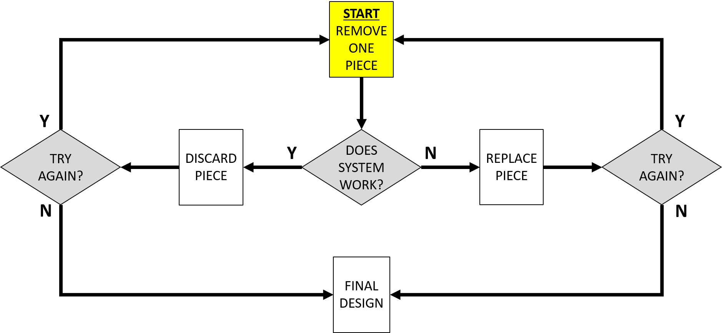

Sounds easy, right? Uh, not so fast.

Before we remove a piece, we’ll need to decide which piece to remove. That means it is time to identify our Removal Strategy.

As with the Stop Strategy, there are several options. We might even use multiple strategies as things progress. Here’s a list to get you started:

- Obviously Extraneous: Are some parts obviously extraneous, patently unnecessary, or blatantly redundant and patently unnecessary? If so, begin by trimming them. This is a good strategy to use when starting out, regardless of the Stop Strategy selected in the previous step.

- Threshold Busters: Does your Stop Strategy involve reaching a particular threshold (size, weight, power, etc)? If so, look for the main contributors to that particular dimension. For example, if you are using a Threshold Strategy to trim 10 pounds off a 100-pound project, don’t waste your time trimming out a piece that only weighs half an ounce (unless you can trim 100 of them). Instead, look for components that are close to the 10-pound range or represent a significant fraction of the desired improvement.

- Speedy Trim: Using the Timebox Strategy for stopping? Aim to minimize the chronological impact of each trim. This could mean using a machete style to quickly make big, rough cuts. Or it might mean using a scalpel to make a quick series of small cuts. In either case, we’re looking for things that can be taken out with minimal delay.

- Acceleration Trim: In this strategy, we are focused on shortening the overall project timeline rather than reducing the amount of time involved with the trimming practice itself. We are looking to trim something that will allow us to ship sooner. As Eric Ries puts it in The Leaders Guide to Adopting Lean Startup, “what can you remove from this so that you can launch tomorrow?”

- Random: Not sure where to start? Sometimes the mere act of starting matters more than the specific item we start with, so start anywhere. Pick anything. See what happens. This exploratory strategy is most effective when dealing with an unfamiliar legacy system or a design where the interactions between components is unclear.

- Obviously Necessary: This strategy is the inverse of the first one on this list, and involves removing things which seem to be essential. This surprising strategy is often effective at revealing incorrect assumptions about which components are truly necessary.

Based on the Stop Strategy from Step 2, which of these Removal strategies make the most sense for your situation? Write a few words about your Removal Strategy in the space below:

Example: Because my project needs to weigh less than 10 lbs and it currently weighs 15 lbs, I will use Strategy #2 (Threshold Busters) and begin by removing components that weigh at least 2 lbs.

My Removal Strategy:

STEP 4: THE TEST

It turns out the most important step in the Trimming practice is not the trimming itself.

Instead, successful application of this tool depends on a test we do after removing a piece. This test is shown in the yellow box in the center of our flowchart below, which asks a very important question: Does the system work?

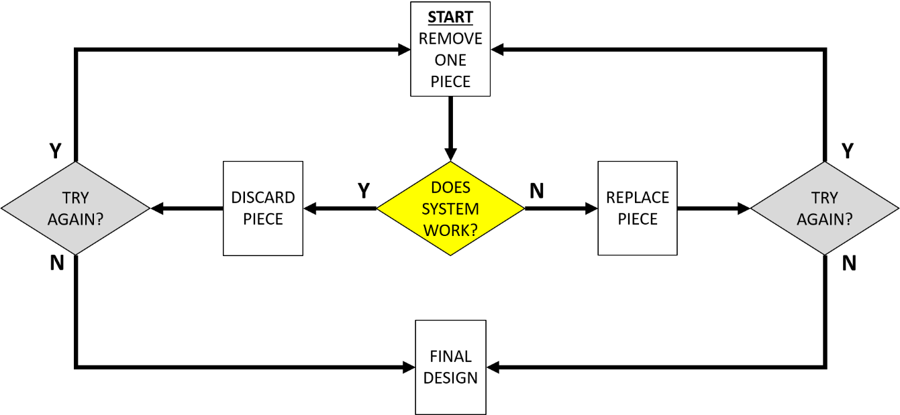

Answering the “Does System Work?” question is where the real Trimming magic happens.

Sometimes the answer will be obviously Yes. We’ll remove the appendix and our patient is just fine. Mission accomplished.

Other times an answer appears obvious but turns out to be wrong. We take the front wheels off a car and the engine still starts when we turn the key, so it looks like everything is ok… until we try to make the car move and discover it cannot. If our test is limited to ignition we’ll overlook the fact that the car is now undriveable, so be sure you test the core function.

And then there are times when the removal of one piece makes the whole tower fall down. The answer is obviously No, the system does not work without that piece. But don’t be too quick to replace the piece just yet – we’ll get to that in the next step.

If we’re dealing with a system that has even a modest amount of complexity, answering this question requires a thoughtful understanding of what “work” really means. Removing a part might change the system’s performance so it no longer does things it used to do… but upon closer inspection we may discover that’s ok.

In order to get to the truth, we have to be willing to experiment a bit.

Can you rearrange or modify the remaining pieces in order to get things running again?

Did you create a hole that needs to be covered, or leave some loose ends dangling?

Do the remaining pieces provide a different type of functionality that is sufficient or even superior to the initial structure?

Consider an automobile. Remove two tires, one headlight, the roof, the doors, the seatbelt, the windshield, and a bunch of other parts. Rearrange the remaining components a bit and we’ll end up with… a motorcycle. Cool, right?

But even if we have a drivable motorcycle, we still must answer the question: Does the motorcycle “work”? The answer depends on what we were trying to accomplish in the first place.

Is the goal to produce a family-friendly transportation option that handles cold weather, wet weather, several kids, and a big load of groceries? If so, the motorcycle probably does not work, no matter how fast or loud or awesome it is.

Is the goal to provide an individual transportation option that makes you feel as cool as the Fonz? If so, then the motorcycle probably does work.

The point is, it is not sufficient to demonstrate that trimming a car into a motorcycle produces a vehicle that burns fuel and can move a rider along a road in a controlled fashion. Instead, we must determine if the capability provided by that motorcycle is the capability we want to provide.

A brief aside: note the question is not “Does System STILL Work?” We may begin with something that currently does not work, and removing some parts might turn a non-functioning artifact into a functioning artifact.

In order to answer this test question, we need an accurate understanding of our goal and we need to know how to do tests that are aligned with the goal. Discovering, defining, and refining the project’s goal is a bigger topic than we’ll cover in this little workbook – for now let’s just raise the issue and suggest it’s important to know what your goal is.

How will you test your system? How will you know if it works?

Writing a document? Read it or ask someone else to read it.

Giving directions? See if someone can follow them.

Writing code? See if it compiles.

Crafting a user interface? Have a potential user try it out and see what they think of it.

Write a few words on the following page about the types of tests you might do in this step. Be sure to include specific words about what it means for your system to “work.” Be as specific as you can. Whenever possible, the test should involve actual users / customers, in actual environments, using the actual thing.

Example: To do my test, I will run an A/B test comparing the visitor click-through rate of the current website and the trimmed version, based on 100 user interactions.

My test will involve:

STEP 5: REPLACE / DISCARD

In the previous step we asked the question “Does the system work?” This appears to be a Yes / No question, and the answer will determine which path we follow in this step.

If the answer is YES, you probably don’t need that part, so slide left to the box labeled Discard Piece.

If the answer is NO, you probably do need that part, so move right towards a box labeled Replace Piece.

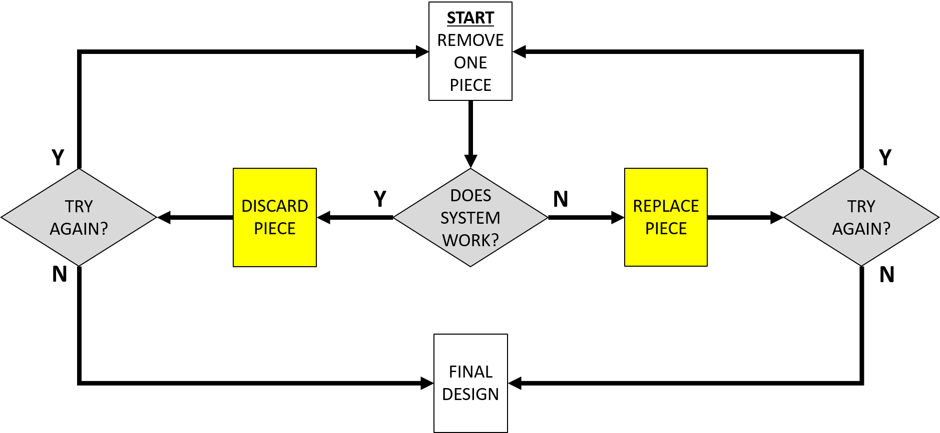

If you’ve read this far, you’re probably not surprised to learn there’s a bit more to it than that.

The question of whether or not the system works appears to be binary.

The motor starts or it does not.
The code complies or it does not.
The document conveys the necessary information or it does not.

But that’s not exactly the end of the story. Sometimes we can remove a piece and the system still works, but the removal nevertheless impoverishes the system and makes it worse than it was before.

The piece may not be essential, but it may still be worthwhile. So along with asking whether the system works, we should also ask the following question:

Is the system better without that piece?

This is a good thing to discuss with the user, customer, or reader, i.e. the projected recipient of the system in question. They are the ones who get final say as to whether the thing is any good. So ask yourself:

How can I connect with a customer or user to determine their assessment of the trimmed design?

Who should I ask to assess the trimmed design?

What would convince them to participate in this discussion?

Alternatively, when we discover the system does not work after we trim something out, putting the thing back is not our only option. Consider the following questions:

What happens if we put part of the thing back, essentially trimming our trim?

Can we introduce a modified version of the removed piece, something to bridge the gap or cover the hole we created when we trimmed it out?

Is it possible to replace the removed piece with something smaller, lighter, cheaper, or otherwise different?

Instead of replacing the piece, can we make the system work by taking out more pieces?

Like I said, it’s a nuanced practice.

In the space below, list some of the people who might be willing to share their opinions about whether or not the system is getting better as it gets trimmed. Write some words about how, when, and where you will consult with them.

List of Opinion-Givers (and how/when/where I will consult them)

STEP 6: TRY AGAIN?

Let’s review for a moment, shall we?

So far in this Trimming process we created a Stop Strategy and a Removal Strategy. We then removed something and tested the system to determine if it works without the thing we removed, then made a nuanced decision (in consultation with users) as to whether to discard or replace the thing we removed.

Now we’re facing another question, shown in the matching yellow boxes below:

Do you want to try again?

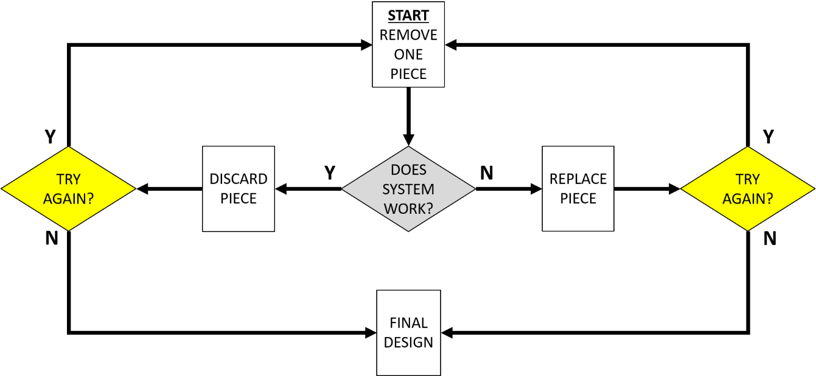

Undertrimming is more common and more problematic than overtrimming, so I suggest our default answer to the “Try again?” question should be yes.

The Stop Strategy once again comes into play.

Did we satisfy the size / weigh / power / etc threshold identified in our Stop Strategy?

Do we have enough time / money / resources / etc left over to go through the process again?

Have we checked every piece? Do we want to?

Is the system better than it was before? Is “better” good enough?

Did our previous removal allow us (or require us) to remove something else?

That last question is key. When we remove a platform, we can also remove the struts that held the platform in place. Take the pilot out of an aircraft and we can also remove the ejection seat, life support system, and dashboard. Because systems tend to be interconnected and interdependent, one removal almost always leads to another.

Let’s borrow another question from Eric Ries’ Leader’s Guide:

“What would your team say if you encouraged them to remove 75% of the current features from your product?”

Sure, trimming out 75% of our planned features is a whole lot of trimming. But that might be precisely the degree of trimming we need. One final quote from Ries:

“…rarely do customers say, ‘Gosh, I wish you’d launched this with more complexity.’”

In the space below, revisit your Stop Strategy and write some reasons you might decide to not keep going. Then be honest about whether these reasons are any good.

My Stop Strategy (redux):

What if I do another trim?

STEP 7: THE FINAL DESIGN

Congratulations! You’ve arrived at a final design.

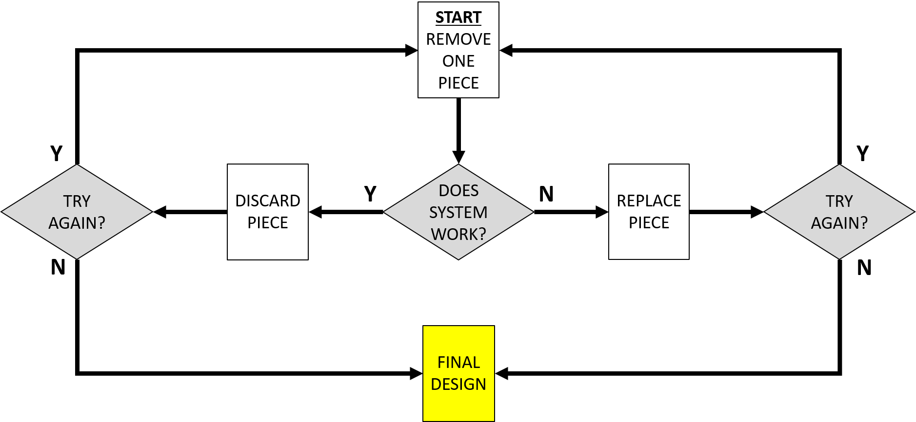

At this point, the project is streamlined and elegant. You’ve removed all the unnecessary components. The final product now does everything it needs to do and nothing it doesn’t need to do. It satisfies the rubric completely, and is not bigger, heavier, or more expensive than we want it to be.

Take a moment to bask in the glory of this achievement.

There is now just one thing left to do: ship it.

Then again… every ending is a beginning. Print out a fresh copy of this workbook and start thinking about what comes next!

About The Author
Dan Ward is the author of F.I.R.E.: How Fast, Inexpensive, Restrained and Elegant Methods Ignite Innovation (HarperBusiness, 2014) and The Simplicity Cycle: A Field Guide To Making Things Better Without Making Them Worse (HarperBusiness, 2015). Prior to joining MITRE, he served for more than 20 years as an acquisition officer in the US Air Force, where he specialized in leading high-speed, low-cost technology development programs and retired at the rank of Lieutenant Colonel.

DISCLAIMER
The author's affiliation with The MITRE Corporation is provided for identification purposes only, and is not intended to convey or imply MITRE's concurrence with, or support for, the positions, opinions, or viewpoints expressed by the author.

